NAME:
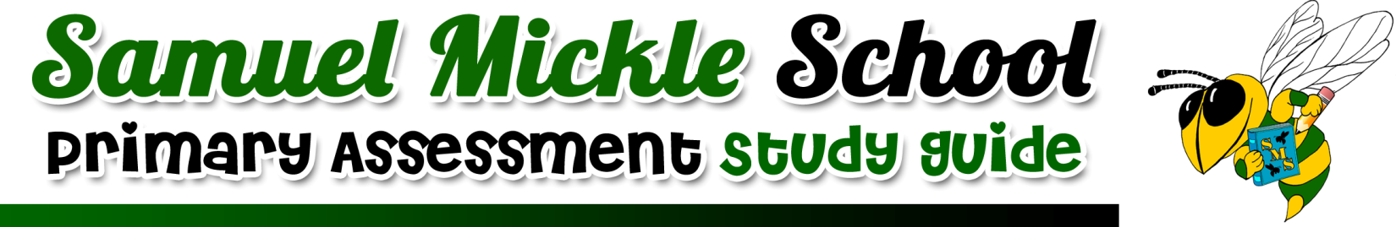
SUBJECT: Literacy- Lesson 2
TEST DATE: Friday, October 4th
IMPORTANT VOCABULARY WE NEED TO APPLY:  peered- to look closely to see something better  pride- to feel proud or satisfied with something  dove- to fall or jump head first  fins- thin, flat structures fish use to swim  locate- to find something  overflowing- something is so full it is spilling out | IMPORTANT CONCEPTS/SKILLS WE LEARNED:  ~using vocabulary words in context of sentences  ~describing a character's traits using their thoughts, words, actions, and feelings  ~summarizing a text using 'somebody, wanted, but, so' strategy  ~using inflected endings (-s, -es, -ed-, -ing)  ~using the RACE strategy to respond to text based questions.
MATERIALS WE CAN USE TO STUDY:
- Reader's Notebooks

-Raz Kids

- Worksheets completed in class
HOW WE STUDIED IN CLASS:
-Whole group review and instruction
-Centers based activities and games
-Small group instruction

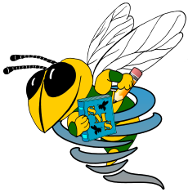
Samuel Mickle School Spiral Skills
IMPORTANT CONCEPTS AND SKILLS WE WILL CONTINUE TO PRACTICE:

Samuel Mickle School Spiral Skills
IMPORTANT CONCEPTS AND SKILLS WE WILL CONTINUE TO PRACTICE:

Samuel Mickle School Spiral Skills
IMPORTANT CONCEPTS AND SKILLS WE WILL CONTINUE TO PRACTICE:

Samuel Mickle School Spiral Skills
IMPORTANT CONCEPTS AND SKILLS WE WILL CONTINUE TO PRACTICE:

