NAME:
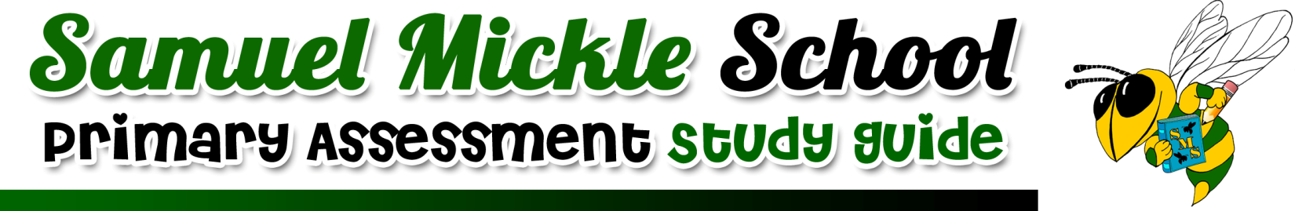
SUBJECT: Literacy- Lesson 4
TEST DATE: Monday, November 5th
IMPORTANT VOCABULARY WE NEED TO APPLY:  experiments- carefully planned tests used to discover something unknown.  improve- make something better  operated- mean to work or run something  invention- something new that someone has created  provided- given what is needed  cause- the reason why something happnes  effect0 the result or what happened  visualize- using details from the text to create a picture in your mind | IMPORTANT CONCEPTS/SKILLS WE LEARNED:  ~Reading a text and identifying the cause and effect relationships using a graphic organizer  ~Using text details to visualize events and settings in a text  ~Using vocabulary words in context  ~Answering text dependent questions using the RACE strategy  ~Defining unfamiliar vocabulary words using context clues strategies
MATERIALS WE CAN USE TO STUDY:
Reader;s Notebooks

Write-in Reader

Raz-Kids

Worksheets completed in class
HOW WE STUDIED IN CLASS:
Whole group instruction

Centers/ Small group instruction

Review activities

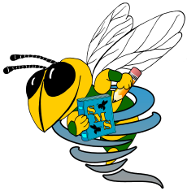
Samuel Mickle School Spiral Skills
IMPORTANT CONCEPTS AND SKILLS WE WILL CONTINUE TO PRACTICE:

Samuel Mickle School Spiral Skills
IMPORTANT CONCEPTS AND SKILLS WE WILL CONTINUE TO PRACTICE:

Samuel Mickle School Spiral Skills
IMPORTANT CONCEPTS AND SKILLS WE WILL CONTINUE TO PRACTICE:

Samuel Mickle School Spiral Skills
IMPORTANT CONCEPTS AND SKILLS WE WILL CONTINUE TO PRACTICE:

