NAME:
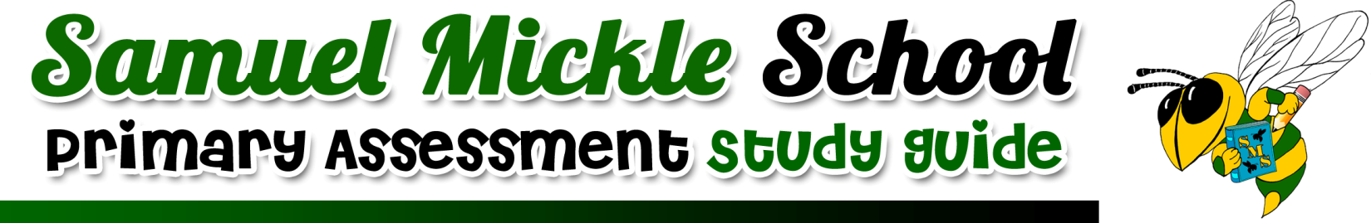
SUBJECT: Literacy- Lesson 1
TEST DATE: Friday, September 20th
IMPORTANT VOCABULARY WE NEED TO APPLY:  gym- a building or room where indoor sports are played  hint- a suggestion not made in a direct way  hunt- to search or try to find something  news- a report of important events  odd- when something is unexpected or out of the ordinary | IMPORTANT CONCEPTS/SKILLS WE LEARNED:  ~Using vocabulary words in sentences  ~Identifying story elements (characters, plot, setting)  ~Summarizing a text read  ~Using text details to respond to questions  ~Using prefixes (re-, un-, dis-) and determining their meaning when attached to a root word
MATERIALS WE CAN USE TO STUDY:
Worksheets completed in class

Reader's Notebooks

Interactive Notebook

Raz-Kids
HOW WE STUDIED IN CLASS:
Independent and small group activities

Centers based activities

Whole group instruction

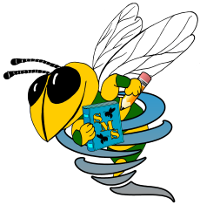
Samuel Mickle School Spiral Skills
IMPORTANT CONCEPTS AND SKILLS WE WILL CONTINUE TO PRACTICE:

Samuel Mickle School Spiral Skills
IMPORTANT CONCEPTS AND SKILLS WE WILL CONTINUE TO PRACTICE:

Samuel Mickle School Spiral Skills
IMPORTANT CONCEPTS AND SKILLS WE WILL CONTINUE TO PRACTICE:

Samuel Mickle School Spiral Skills
IMPORTANT CONCEPTS AND SKILLS WE WILL CONTINUE TO PRACTICE:

